REPORT

|  |  |
| --- | --- |
| **TEAM ID :** | **PNT2022TMID14299** |
| **PROJECT NAME :** | **PERSONAL ASSISTANCE FOR SENIORS WHO ARE SELF-RELIANT** |

**1. INTRODUCTION**

**1.1. Project Overview**

Sometimes elderly people forget to take their medicine at the correct time. They also forget which medicine He / She should take at that particular time. And it is difficult for doctors/caretakers to monitor the patients around the clock. To avoid this problem, this medicine reminder system is developed. An app is built for the user (caretaker) which enables him to set the desired time and medicine. These details will be stored in the IBM Cloudant DB. If the medicine time arrives the web application will send the medicine name to the IoT Device through the IBM IoT platform. The device will receive the medicine name and notify the user with voice commands.Here Node-red connects the Web UI, Cloudant DB and IBM Watson IoT platform.

**1.2. Purpose**

The major purpose of this project is to help the elderly people who can assist themselves with the help of an voice alarm to take medicine at correct time. This avoids the irregular intake of medicine and keeps their body healthy. Some elderly people have oblivion to take medicine at right time but they can assist themselves in all other works these type of elderly people will make of this project to their best. This method of medicine alerts also avoids the need of personal care assistance expences and man power.

**2. LITERATURE SURVEY**

**2.1. Existing problem**

The aging of population is a global issue all over the world and as the people start aging it is a common problem of getting diseases such as cholestrol, diabetes, blood pressure, etc, . It is not possible to assist elderly people with our presence with them to take medicine at correct time, some elderly people have a problem in taking medicine at correct time and get confused to take which medicine due to forgetness, this leads to severe health issues for elderly people. To avoid this Existing problem new method is proposed to help elderly people to get voice messages to take which type of medicine at what time as an alert.

**2.2. References**

1. A. Wong, Population Aging and the Transmission of Monetary Policy to Consumption, 2015, <https://economics.stanford.edu/sites/default/files/arlene_wong_jmp_latest-2g9f9ga.pdf>.
2. B. Ma, The Monitor System of Elderly People Living Alone Based on the Comprehensive Computer Vision, Zhejiang University of Technology, 2014.
3. Y. Bai, J. Li, and J. He, “The design of the fall detection system based on embedded video monitoring,” Television Technology, vol. 38, no. 15, 2014.

             View at: [Google Scholar](https://scholar.google.com/scholar_lookup?title=The%20design%20of%20the%20fall%20detection%20system%20based%20on%20embedded%20video%20monitoring&author=Y.%20Bai&author=J.%20Li&author=J.%20He&publication_year=2014)

1. L. Liu, E. Stroulia, I. Nikolaidis, A. Miguel-Cruz, and A. Rios Rincon, “Smart homes and home health monitoring technologies for older adults: a systematic review,” International Journal of Medical Informatics, vol. 91, pp. 44–59, 2016.

             View at: [Publisher Site](https://doi.org/10.1016/j.ijmedinf.2016.04.007) | [Google Scholar](https://scholar.google.com/scholar_lookup?title=Smart%20homes%20and%20home%20health%20monitoring%20technologies%20for%20older%20adults%3A%20a%20systematic%20review&author=L.%20Liu&author=E.%20Stroulia&author=I.%20Nikolaidis&author=A.%20Miguel-Cruz&author=A.%20Rios%20Rincon&publication_year=2016)

1. A. Jacobsson, M. Boldt, and B. Carlsson, “A risk analysis of a smart home automation system,” Future Generation Computer Systems, vol. 56, pp. 719–733, 2015.

             View at: [Publisher Site](https://doi.org/10.1016/j.future.2015.09.003) | [Google Scholar](https://scholar.google.com/scholar_lookup?title=A%20risk%20analysis%20of%20a%20smart%20home%20automation%20system&author=A.%20Jacobsson&author=M.%20Boldt&author=B.%20Carlsson&publication_year=2015)

1. C. D. Kidd, R. Orr, G. D. Abowd et al., The Aware Home: a Living Laboratory for Ubiquitous Computing Research International Workshop on Cooperative Buildings, Springer, Berlin Heidelberg, 1999.

**2.3. Problem Statement Definition**

                          Personal Assistance for elderly people for alerting them to take medicine on time is designed for helping the seniors who are self - reliant. The alerting mechanism also includes the medicine details for specific users so that it will be easy for them to find their medicine and take it at right time.

**3. IDEATION & PROPOSED SOLUTION**

**3.1. Empathy Map**

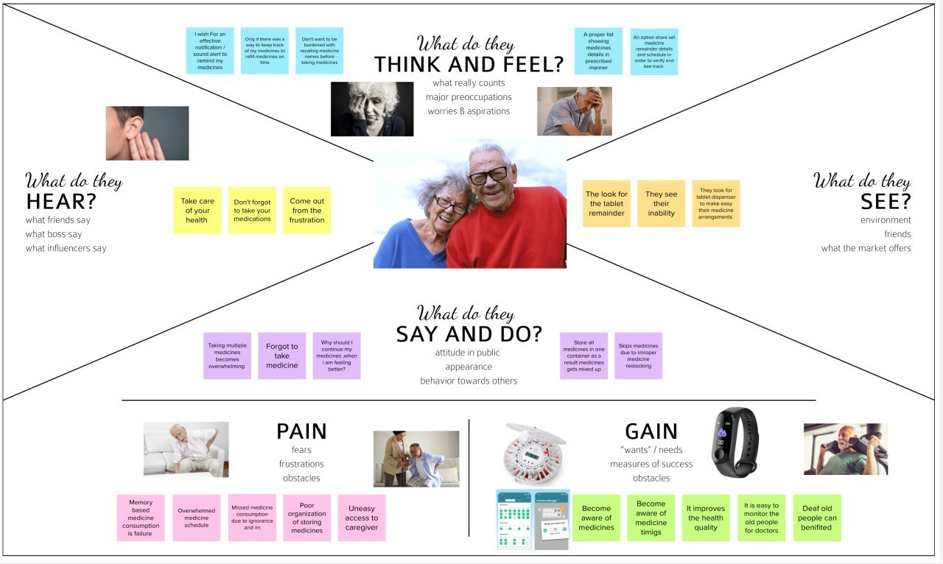

**3.2. Ideation & Brainstorming**

Step-1: Team Gathering, Collaboration and Select the Problem Statement

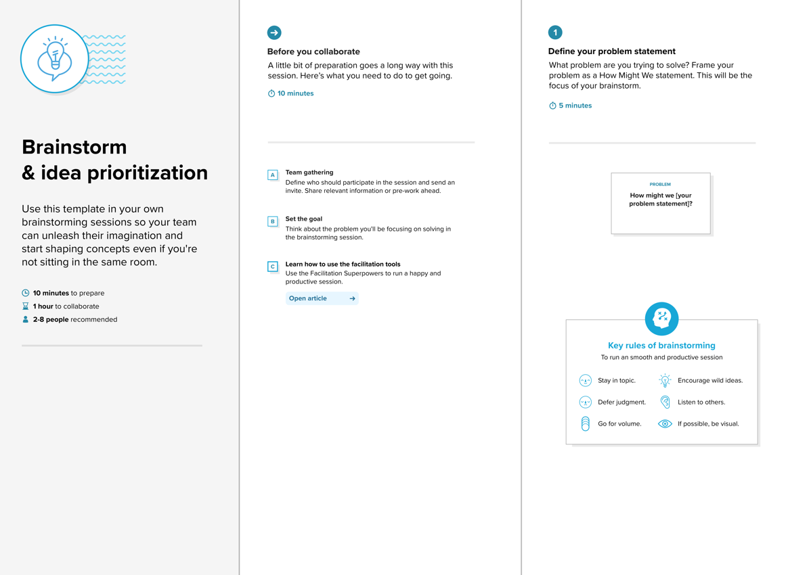

Step-2: Brainstorm, Idea Listing and Grouping

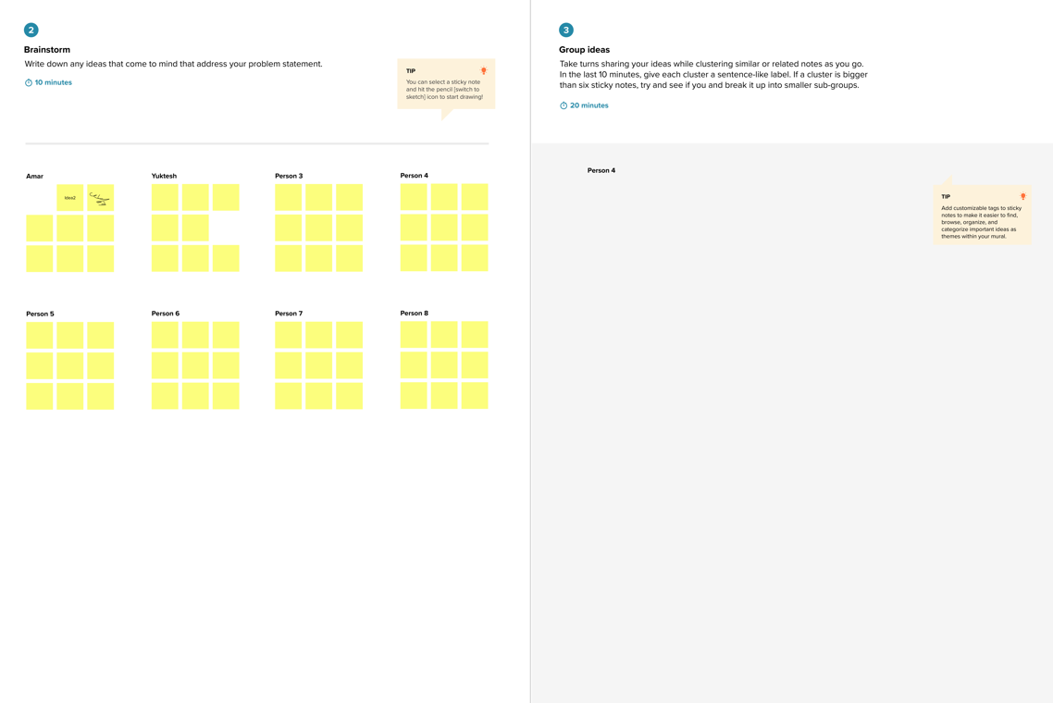

Step-3: Idea Prioritization

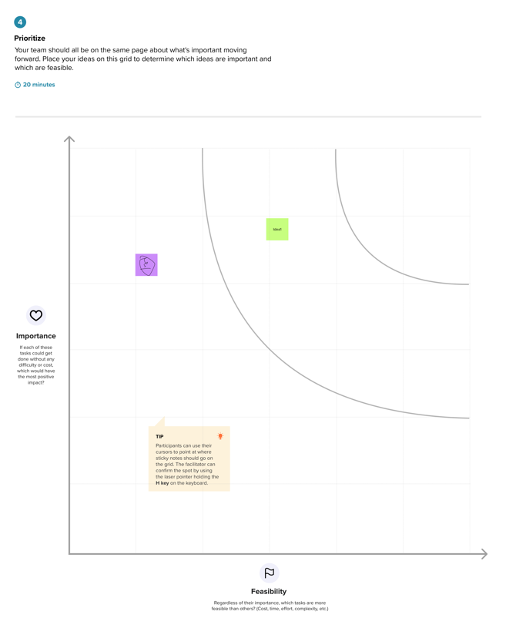

**3.3. Proposed Solution**

|  |  |  |
| --- | --- | --- |
| **S.No.** | **Parameter** | **Description** |
|  | Problem Statement (Problem to be solved) | Sometimes elderly people forget to take their medicine at the correct time. They also forget which medicine He / She should take at that particular time. And it is difficult for doctors/caretakers to monitor the patients around the clock. To avoid this problem, this medicine reminder system is developed .An app is built for the user (caretaker) which enables him to set the desired time and medicine. |
|  | Idea / Solution description | we introduce a smart medicine reminder system based on IoT. The proposed scheme was particularly created for the Android platform. For our system, we implement a reminder system which provides an alarmwhen it is time for taking medicine. Along with that, there is an android application where the user can set their medicine time. In the application, there will some feature that help the user to know more details about their medicine. It keeps track for the medicine which means how much medicine they have to take they can be fixed in the application |
|  | Novelty / Uniqueness | It is a user-friendly app that sends users medicationand refill reminders, provides drug interaction warnings, and helps caregivers manage prescriptions for lovedones |
|  | Social Impact / Customer Satisfaction | I constructed these proto-personas, or names, based onthe research findings from the user interview. Theywould be crucial to the rest of the design process. Alldesign decisions may be assessed and re-evaluated usingthese personas, keeping the user and their perspectivein mind. |
|  | Business Model (Revenue Model) | When it comes to the business there is no one-size-fits- all solution. The model you choose depends on yourtarget audience , business goals , and the resources youalready possess. |
|  | Scalability of the Solution | where the user can set their medicine time. In the application, there will some feature that help the user to know more details about their medicine. It keeps track for the medicine which means how much medicine they have to take they can be fixed in the application |

**3.4. Problem Solution fit**

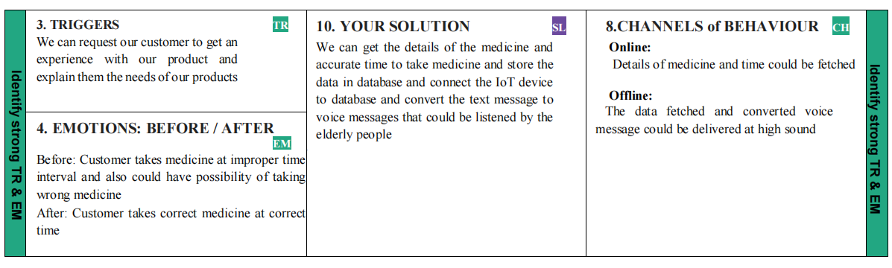

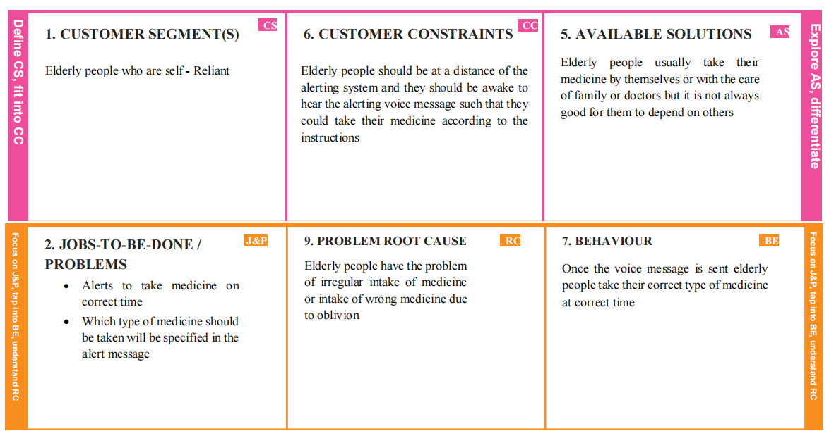

**4. REQUIREMENT ANALYSIS**

**4.1. Functional requirement**

|  |  |  |
| --- | --- | --- |
| **FR No.** | **Functional Requirement (Epic)** | **Sub Requirement (Story/ Sub-Task)** |
| FR-1 | User Registration | Registration through Form  Registration through Gmail Registration throughLinkedIN |
| FR-2 | User Confirmation | Confirmation via Email  Confirmation via OTP |
| FR-3 | User Login | login through User Id and Password. |
| FR-4 | Network Connectivity | via wifi /mobile data. |
| FR-5 | IBMIoT Platform | Access cloud storage via internet and it gives  medication information. |
| FR-6 | Node-RED | Uses to transfer the data fromIOT platform to UI  platform and helpsin storing the data. |

**4.2. Non-Functional requirements**

|  |  |  |
| --- | --- | --- |
| **FR No.** | **Non-Functional Requirement** | **Description** |
| NFR-1 | **Usability** | It can easily track and monitor the medication time  of users and share the information to the caregivers. |
| NFR-2 | **Security** | Thecloudant database is highly secured and it  prevents data fromhacking. |
| NFR-3 | **Reliability** | Theprescription of medication for users is assured  all the time. |
| NFR-4 | **Performance** | It reminds users to take their medications and get themrefilled, warns about druginteractions, and  assists caregivers in managing prescriptions. |
| NFR-5 | **Availability** | Tokeep track the medication of users. |
| NFR-6 | **Scalability** | The users can set the time for their medication and alsocan adjust how much medication to take within  the application. |

**5. PROJECT DESIGN**

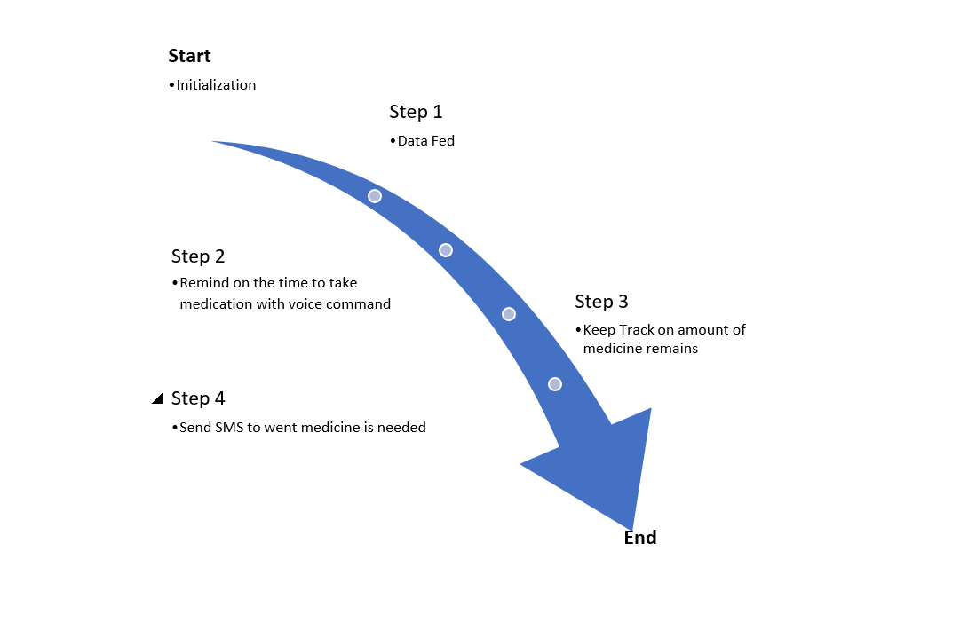**5.1. Data Flow Diagrams**

**5.2. Solution & Technical Architecture**

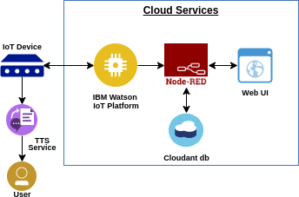

**Table-1: Components & Technologies:**

|  |  |  |  |
| --- | --- | --- | --- |
| **S. No** | **Component** | **Description** | **Technology** |
| 1. | User Interface | Mobile App | MIT |
| 2. | Application Logic-1 | Gathering medicine details and check thetimings | Python |
| 3. | Application Logic-2 | alarms | IBM Watson |
| 4. | Cloud Database | Database Serviceon Cloud | IBM Cloudant DB |

**Table-2: Application Characteristics:**

|  |  |  |  |
| --- | --- | --- | --- |
| **S. No** | **Characteristics** | **Description** | **Technology** |
| 1. | Open-Source Frameworks | Mobile application development setup, programming the IoTdevice, text to speechservice,  storing details in cloud | MIT, IBM Watson,node red, IBM cloud |
| 2. | Security Implementations | Implementing encryption for security purpose | SHA-256. |
| 3. | Scalable Architecture | Application is able to load as many membersaslogged in | MIT, IBM Watson |
| 4. | Availability | Application is available 24/7 | MIT, IBM Watson, node  red, IBM cloud |
| 5. | Performance | Reminder with correct timing | IBM Watson, IBMIoT Platform |

**5.3. User Stories**

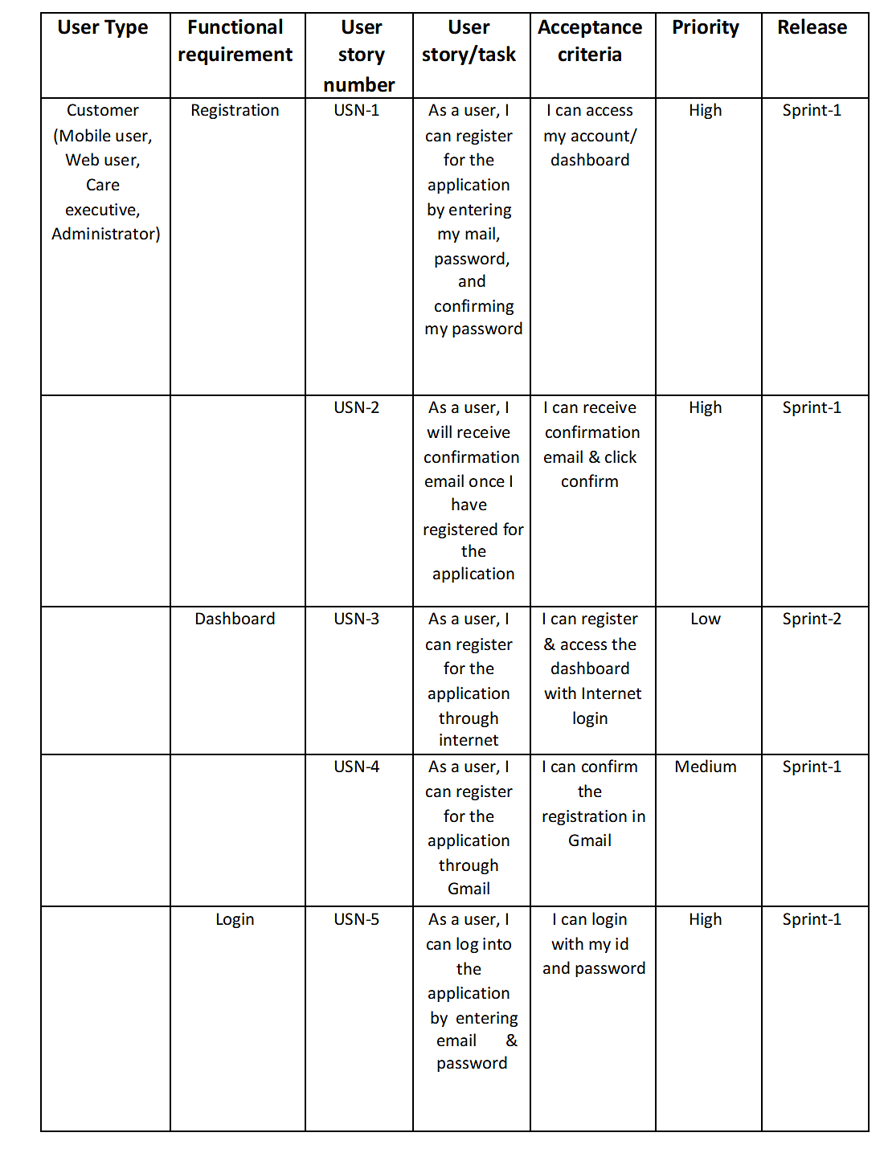

1. **PROJECT PLANNING & SCHEDULING**

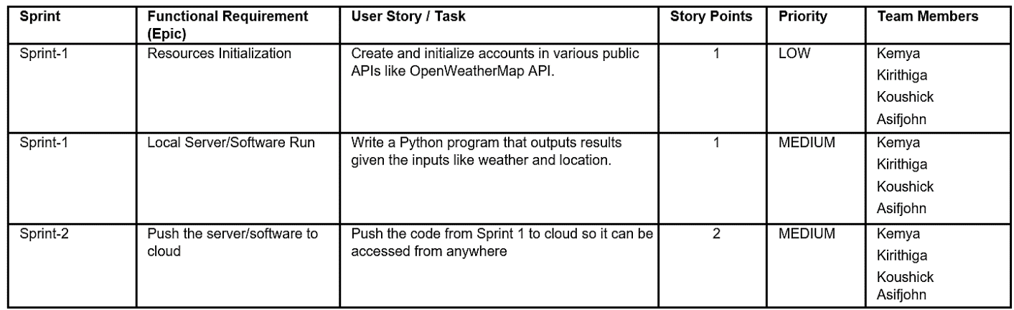

**7. CODING & SOLUTIONING**

**7.1. Feature 1**

* IoT Device
* IBM Watson platform
* Node - Red
* Cloudant DB
* Web UI
* MIT App Inventor
* Python Code

**7.2. Feature 2**

* Login
* Wokwi

**8. TESTING**

**8.1. Test Cases**

This report shows the number of test cases that have passed, failed, and untested.

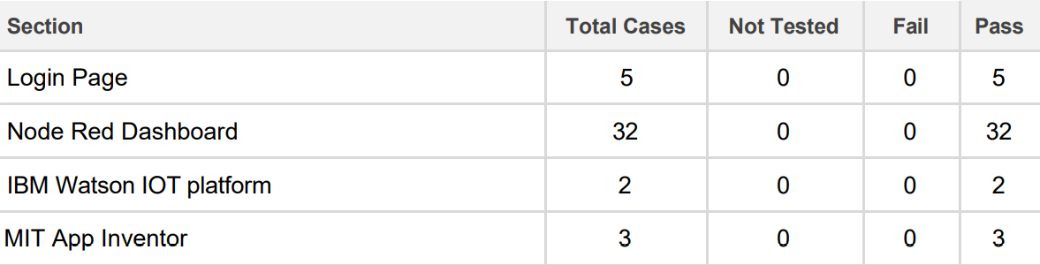

**Test Case 1:**

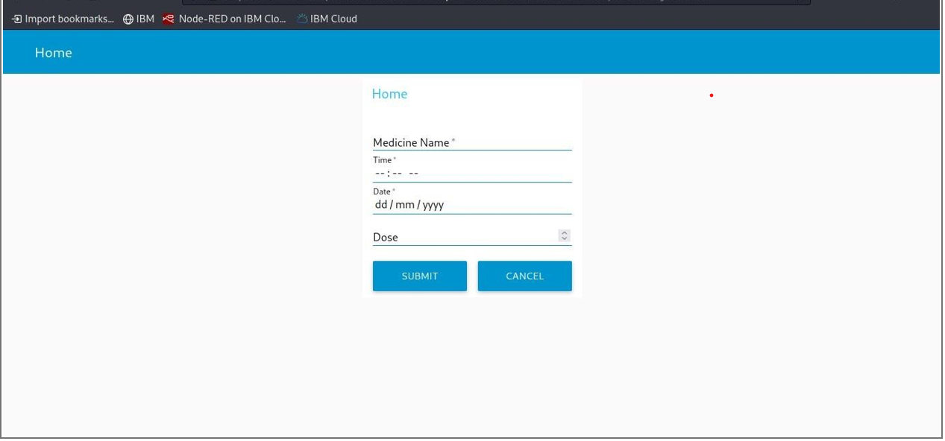

**8.2. User Acceptance Testing**

The main Purpose of UAT is to validate end to end business flow. It does not focus on cosmetic errors, spelling mistakes or system testing. User Acceptance Testing is carried out in a separate testing environment with production-like data setup. It is kind of black box testing where two or more end-users will be involved.

                    UAT is performed by :

                                            • Client

                                            • End user

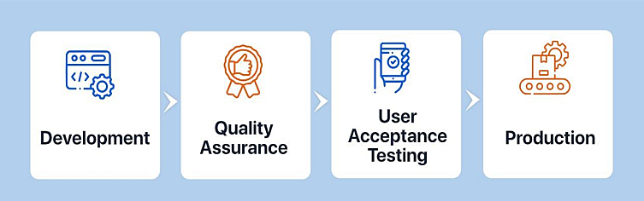

**Defect Analysis**

This report shows the number of resolved or closed bugs at each severity level, and how they were resolved.

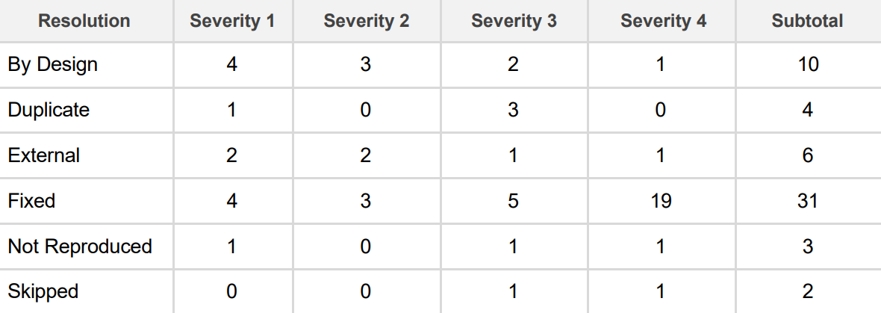

**9. RESULTS**

**9.1. Performance Metrics**

An experiment is conducted on an elderly person who is in need of Personal Assistant Device and the following results are obtained, it shows the medicine reminder that gives the information regarding the intake of medicine by the person using the personal Assistant Device. The stored data in cloudant database on specified time alerts user with a voice message.

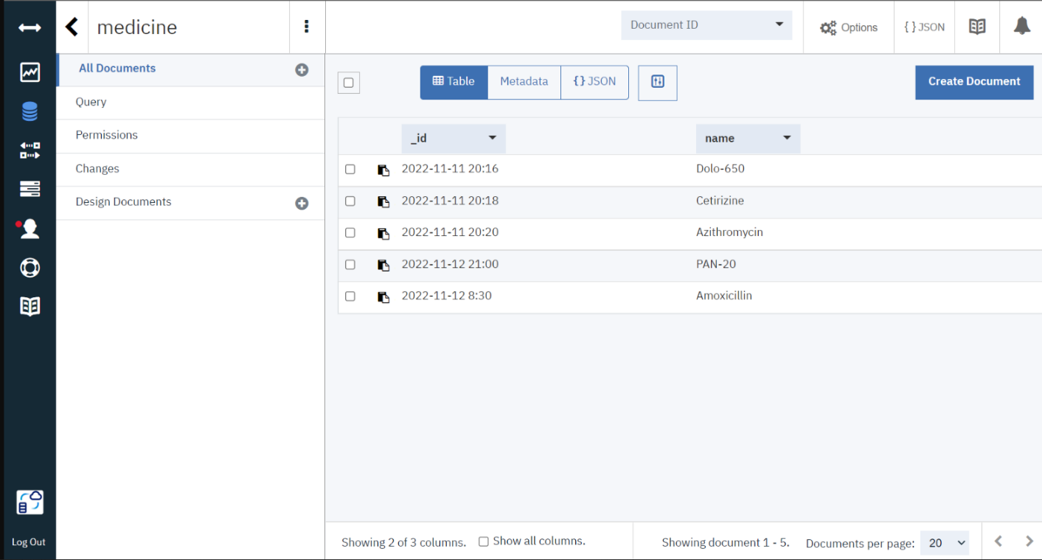

**10. ADVANTAGES & DISADVANTAGES**

**ADVANTAGES**

* Availability

One of the primary preferences of possessing a PDA is the capacity to stay in contact with individuals through email, text informing and telephone. Since PDAs are so convenient and networks so broad, clients can take them anyplace.

* Association

Another advantage of possessing a PDA is expanded association. Schedule and rundown applications make it simple to monitor arrangements, make notes in a hurry and document past discussions or other information.

* Status

For some PDA clients, the gadget has the additional advantage of meaning a specific status. Organization gave PDAs might be held for more significant level representatives and can come to connote a place of power or significance. For individual clients, having the most recent PDA might be an indication of riches or innovative information.

* Broad Internet Connectivity

For occupied people, the primary preferred position of getting a PDA is being able to remain associated through email, calls, text informing and different courier applications. These are worked with broad organization network so clients can get to the Internet anyplace they are.

**DISADVANTAGES**

* Cost

One of the greatest hindrances of a PDA is the expense. Other than paying for the gadget itself, most PDAs require the purchaser to buy in to a utilization contract. This includes a month to month bill and the chance of overage charges if the client outperforms his designated free telephone minutes or information limits.

* Interruption

PDAs may likewise turn into an interruption when they’re not satisfying an authentic need. The capacity to be constantly associated can prompt sat around riding the Web, settling on telephone decisions or messing around. Some business clients whine of being “available to come in to work” when their colleagues and bosses can reach them whenever.

* Restricted in Scope

PDAs are restricted in degree. They are neither PC substitutions nor would they be able to be successfully used to supplant mobile phones. PDAs are not furnished to manage miniature preparing capacities.

* Time constraint

PDAs are not generally the best response to business arrangements. Paper-based coordinators are a more reasonable choice since PDAs are hard to utilize, information passage is abnormal, they are moderate and beginner clients discover them superfluously unpredictable.

**11. CONCLUSION**

With the continuously increasing utilization of internet in this point in time, this assignment paintings has been engaged to execute a framework depending on web innovation which could discuss through internet for health checking of patients and for giving assist to vintage people. It utilized to apprehend the development of patient which sends this statistics to everything communicate producer to reveal the readings . During the crisis situations, a caution might be raised over the internet level telling the expert/overseer by way of the patient simply by squeezing a seize in the helpful machine. This offers a trustworthy framework which can screen the well-being reputation continuously of a patient or an vintage individual.

**12. FUTURE SCOPE**

Whether or not the role of IoT as the best solution to provide help for the weak elderly citizens is accepted, yet these people are certainly in need of care. There are some strong and determined persons who manage to preserve their mind and body active until an old age. Still there are many who are in need of aid in their routine life as well as those people who totally depend on others. It provides an effective homecare monitoring and care support for elderly people by communication and coordination with professional helpers and thereby improving the quality for independent life of old aged.Future elder care IoT projects  will also more than likely have the ability to take on medical diagnostics, as well as use facial recognition algorithms to determine how someone is feeling.But despite all of this future capability, there still exists a dichotomy of things that IoT can do way better than humans and things they simply cannot do at all. For instance, an elder care IoT based projects  in the future may easily be able to find and retrieve a pill box from another room, however, without an excellent mobility system, it will be stopped dead in its tracks should it get caught on something along the way. Collaboration and integration between researchers, private industry, investors, and the government will be key in the years to come.

**13. APPENDIX**

**13.1. Source Code**

#include <WiFi.h>//library for wifi

#include <PubSubClient.h>//library for MQtt

#include <LiquidCrystal_I2C.h>

#define LED 2

void callback(char* subscribetopic, byte* payload, unsigned int payloadLength);

//-------credentials of IBM Accounts------

#define ORG "88ju36"//IBM ORGANITION ID

#define DEVICE_TYPE "Node-MCU"//Device type mentioned in ibm watson IOT Platform

#define DEVICE_ID "2"//Device ID mentioned in ibm watson IOT Platform

#define TOKEN "123456789"     //Token

String data3="";

//-------- Customise the above values --------

char server[] = ORG ".messaging.internetofthings.ibmcloud.com";// Server Name

char publishTopic[] = "iot-2/evt/Data/fmt/json";// topic name and type of event perform and format in which data to be send

char subscribetopic[] = "iot-2/cmd/command/fmt/String";// cmd  REPRESENT command type AND COMMAND IS TEST OF FORMAT STRING

char authMethod[] = "use-token-auth";// authentication method

char token[] = TOKEN;

char clientId[] = "d:" ORG ":" DEVICE_TYPE ":" DEVICE_ID;//client id

LiquidCrystal_I2C lcd(0x27,16,2);

//-----------------------------------------

WiFiClient wifiClient; // creating the instance for wificlient

PubSubClient client(server, 1883, callback ,wifiClient); //calling the predefined client id by passing parameter like server id,portand wificredential

void setup()// configureing the ESP32

{

  Serial.begin(115200);

  pinMode(LED,OUTPUT);

  delay(10);

  Serial.println();

  wificonnect();

  mqttconnect();

}

void loop()// Recursive Function

{

  if (!client.loop()) {

    mqttconnect();

  }

}

/*.....................................retrieving to Cloud...............................*/

void mqttconnect() {

  if (!client.connected()) {

    Serial.print("Reconnecting client to ");

    Serial.println(server);

    while (!!!client.connect(clientId, authMethod, token)) {

      Serial.print(".");

      delay(500);

    }

     initManagedDevice();

     Serial.println();

  }

}

void wificonnect() //function defination for wificonnect

{

  Serial.println();

  Serial.print("Connecting to ");

  WiFi.begin("Wokwi-GUEST", "", 6);//passing the wifi credentials to establish the connection

  while (WiFi.status() != WL_CONNECTED) {

    delay(500);

    Serial.print(".");

  }

  Serial.println("");

Serial.println("WiFi connected");

  Serial.println("IP address: ");

  Serial.println(WiFi.localIP());

}

void initManagedDevice() {

  if (client.subscribe(subscribetopic)) {

    Serial.println((subscribetopic));

    Serial.println("subscribe to cmd OK");

  } else {

    Serial.println("subscribe to cmd FAILED");

  }

}

void callback(char* subscribetopic, byte* payload, unsigned int payloadLength)

{

  Serial.print("callback invoked for topic: ");

  Serial.println(subscribetopic);

  for (int i = 0; i < payloadLength; i++) {

    //Serial.print((char)payload[i]);

    data3 += (char)payload[i];

  }

  Serial.println("Please take "+ data3);

  if(data3 != "")

  {

    lcd.init();

    lcd.print("Take"+ data3);

digitalWrite(LED,HIGH);

delay(20000);

digitalWrite(LED,LOW);

  }

  else

  {

digitalWrite(LED,LOW);

 }

data3="";

}

**13.2. GitHub Link**

 [**https://github.com/IBM-EPBL/IBM-Project-10188-1659110752**](https://github.com/IBM-EPBL/IBM-Project-10188-1659110752)